Institut de Chimie des Substances Naturelles

Labeling bacterial membranes using biorthogonal chemistry
Boris Vauzeilles
Chemical Biology Department, ICSN, CNRS UPR 2301, Université Paris-Saclay, 91198 Gif-sur-Yvette (France);
Synthesis of Bioactive Molecules and Macromolecules, ICMMO, CNRS UMR 8182, Univ. Paris-Sud, Université Paris-Saclay, 91405 Orsay (France).
boris.vauzeilles@cnrs.fr
In the pre-antibiotic era, bacterial infections could have serious consequences, and some epidemic outbreaks often proved dramatic. During the 20th century, the discovery of these molecules considerably impacted our life conditions. Some bacteria remain however difficult to treat or to detect, and the development of resistant strains, combined with their rapid diffusion within our globalized societies, have considerably reduced our antibiotic arsenal. Epidemic outbreaks can regularly have severe sanitary, but also economic impact. Rapid detection and identification of bacteria remains therefore a major challenge.

We are developing an approach to address this question, relying on metabolic labeling of the bacterial cell surface. As an example, the external membrane of Gram-negative bacteria is covered by a dense lipopolysaccharide layer (LPS) which is involved in cell integrity, but also in the virulence of some strains.

Our recent work has shown that, when metabolically active, Gram-negative bacteria, can specifically incorporate a chemically modified, azide-containing monosaccharide within their LPS. This bioorthogonal reporter group can then be used to "reveal" labeled bacteria, using a click-chemistry ligation method. This strategy allows for rapid detection of live pathogenic bacteria.
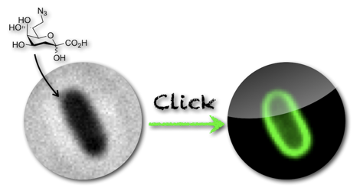
This lecture will present our major and most recent results in this field.

References
- A. Dumont, A. Malleron, M. Awwad, S. Dukan, B. Vauzeilles Angew. Chem. Int. Ed. 2012, 51, 3143-3146.
- J. Mas Pons, A. Dumont, G. Sautejeau, E. Fugier, A. Baron, S. Dukan, B. Vauzeilles Angew. Chem. Int. Ed. 2014, 53, 1275-1278.
- E. Fugier, A. Dumont, A. Malleron, E. Poquet, J. Mas Pons, A. Baron, B. Vauzeilles, S. Dukan, PLoS ONE 2015, 10(6): e0127700.
- C. Cabriel, N. Bourg, P. Jouchet, G. Dupuis, C. Leterrier, A. Baron, M.-A. Badet-Denisot, B. Vauzeilles, E. Fort, S. Lévêque-Fort, Nature Commun., 2019, 10:1980 | https://doi.org/10.1038/s41467-019-09901-8
- E. Lesur, A. Baron, C. Dietrich, M. Buchotte, G. Doisneau, D. Urban, J.-M. Beau, N. Bayan, B. Vauzeilles, D. Guianvarc’h, Y. Bourdreux, Chem Commun., 2019, DOI: 10.1039/C9CC05754D

