SHORT BIOGRAPHY

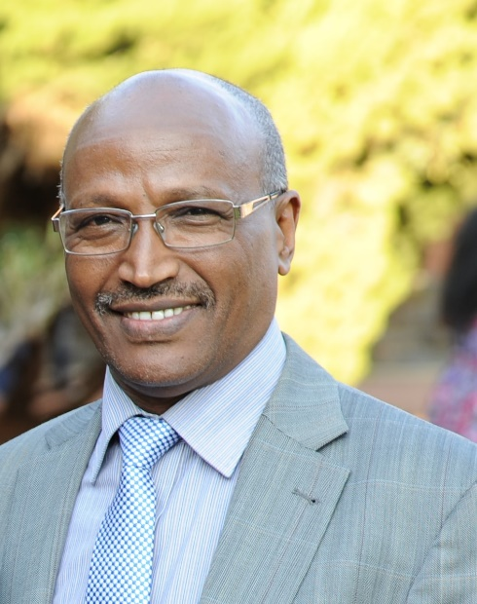
Prof Yali E. Woyessa, PhD | MBA | Fulbright Scholar
Assistant Dean: Research, Innovation and Engagement
Faculty of Engineering, Built Environment and Information Technology.
Central University of Technology, Free State, Bloemfontein, South Africa.
Email: ywoyessa@cut.ac.za

Professor Yali Woyessa has been involved in teaching and research in higher education institutions for more than 30 years. He is a Fulbright Scholar with a PhD degree from the University of Free State in South Africa and MSc from L’Institut Agro Montpellier (formerly known as ENSAM) in France. In addition, he has obtained two more Masters degrees (MA in Higher Education Studies and MBA) from the University of Free State. His research interest includes water resources management, hydrology, water security, land-water linkages, and climate change. He has published two books and more than 50 papers in peer reviewed journals and conference proceedings. He currently serves as Assistant Dean for Research, Innovation and Engagement in the Faculty of Engineering, Built Environment and Information Technology at the Central University of Technology, Free State, in South Africa.

